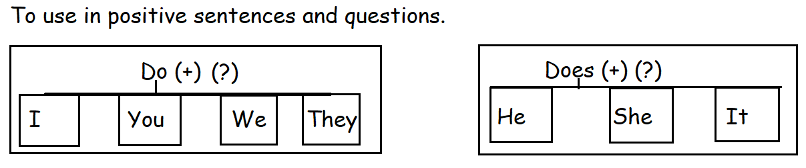
Complete the sentences using do/does.
1._________ she like to dance? Yes, she ________.
2._________ they play soccer? Yes, they ________.
3. ________ Roberto eat vegetables? Yes, he _______.
4._______ we practice football? Yes, we ______.
5. ______ you listen to rock music? Yes, I _____.

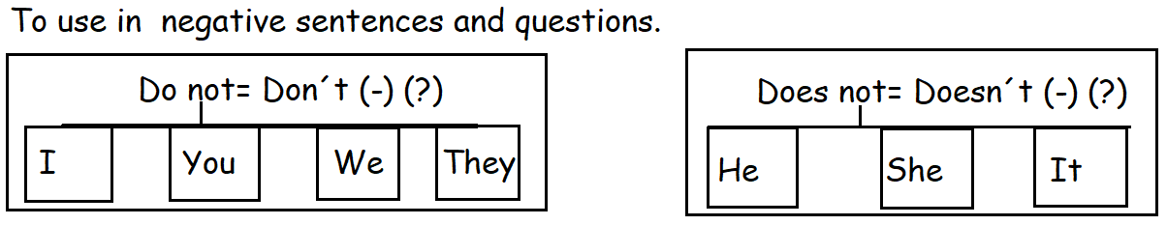

Complete the sentences using: don´t / doesn´t.
1.Does a koala eat ice cream? No. it ______________.
2.Do you drink coffee? No, I _____________.
3.Does Katy speak japanese? No, she ____________.
4. Does your dog eat chocolate? No, it ____________.
5.Do dolphins live in trees? No, they _____________.

Question Words. Use them to get information about…
Why | Reasons
Who | Person/people
What | Things
Where | Places/Locations
When | Time

Present Progressive Tense.
Positive sentences.
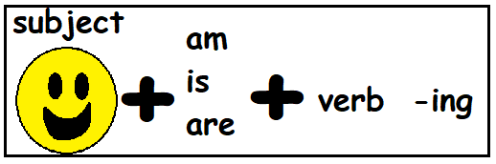
Examples:
He is reading a book.
You are eating a fruit.
We are drinking water.
Exercise: Change the sentences into present progressive.
Examples: I do my homework. = I am doing my homework.
He writes a letter= He is writing a letter.
They eat ice cream. = They are eating ice cream.
1.I play soccer. ________________________________________
2. You sleep on the sofa. __________________________________
3. He reads books. _______________________________________
4. They study English. _____________________________________
5.We drink water. ________________________________________

Present Progressive Negative Sentences.
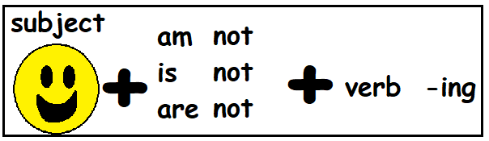
Examples:
I play basketball. I am not playing basketball.
You drink milk. You are not drinking milk.
She swims in the pool. She is not swimming in the pool.
They build a snowman. They are not building a snowman.
Exercise: Change the sentences into the Present Progessive Negative Tense.
1.They read comics. ________________________________________

2.I visit my grandma. _______________________________________

3.We go to the park. ______________________________________

4. You play bingo. ____________________________________________

5. I run in the yard. __________________________________________

Present Progressive Questions.
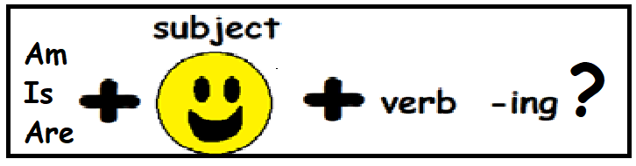
Examples: 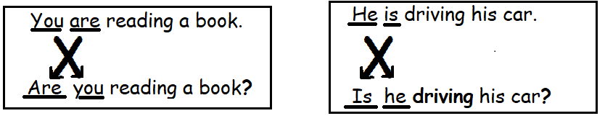
Exercise: Change the statements into questions.
1.She is buying in the supermarket.
________________________________________________________
2.We are taking an exam.
________________________________________________________
3. He is studying very hard.
__________________________________________________________
4. You are going to the farm.
__________________________________________________________
5. They are watching a video on YouTube.
__________________________________________________________

